OPSC6311 POE
FlowFund System Implementation and Code Overview

Group participants:
ST10457568 [TINOTENDA MARUMAHOKO]
ST10454395 [CAMERON REECE JOHANNES]
ST10451742 [WASAMA MAKOLO]
ST10438423[LIAM FRANS]

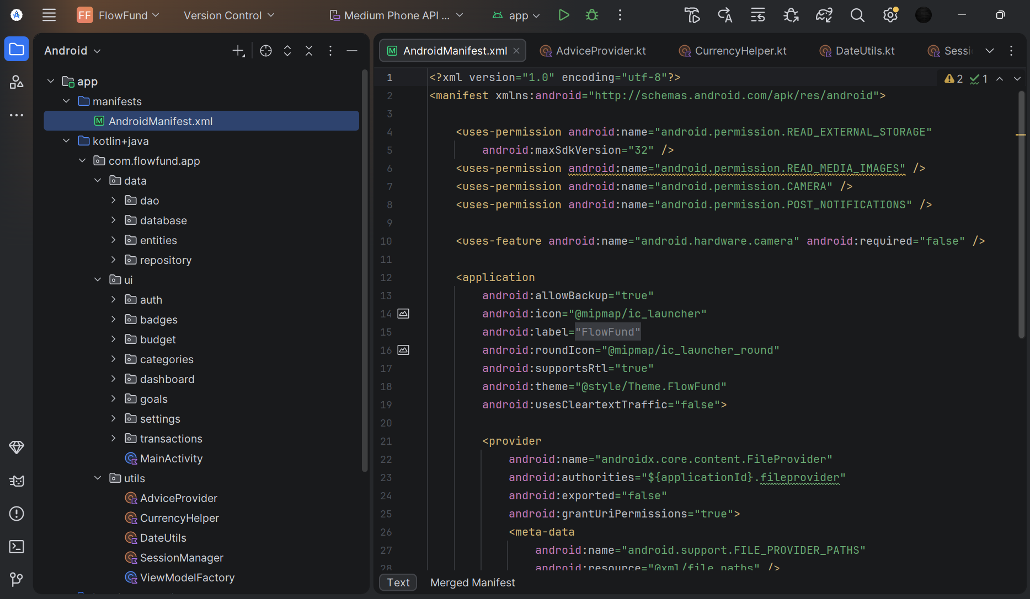
Figure 1:This Android Manifest file configures the basic settings of the app. It allows the app to access images, use the camera, and send notifications. It also sets up secure file sharing through a FileProvider. The LoginActivity is the first screen that opens

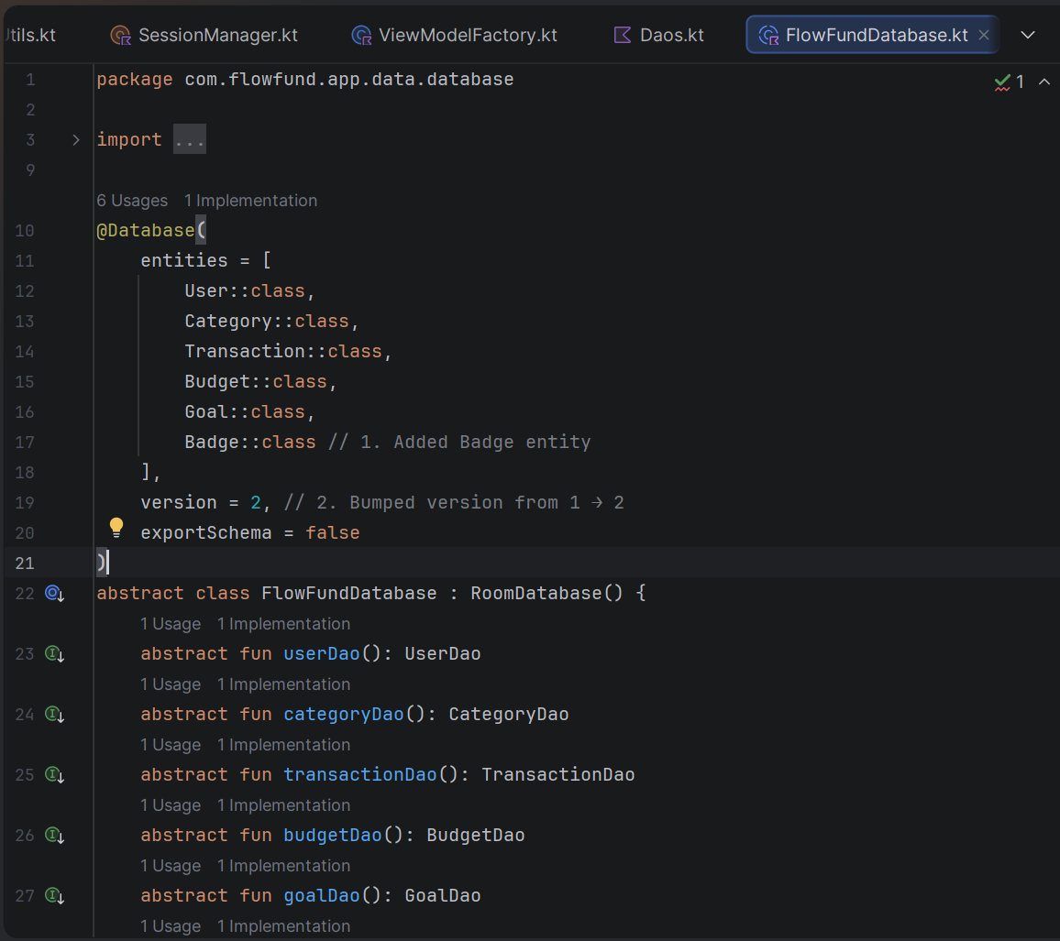
Figure 2: This code creates and manages the app's Room database, called FlowFundDatabase. It stores data for users, categories, transactions, budgets, goals, and badges. The class provides access to different database tables through DAO functions. It also uses a

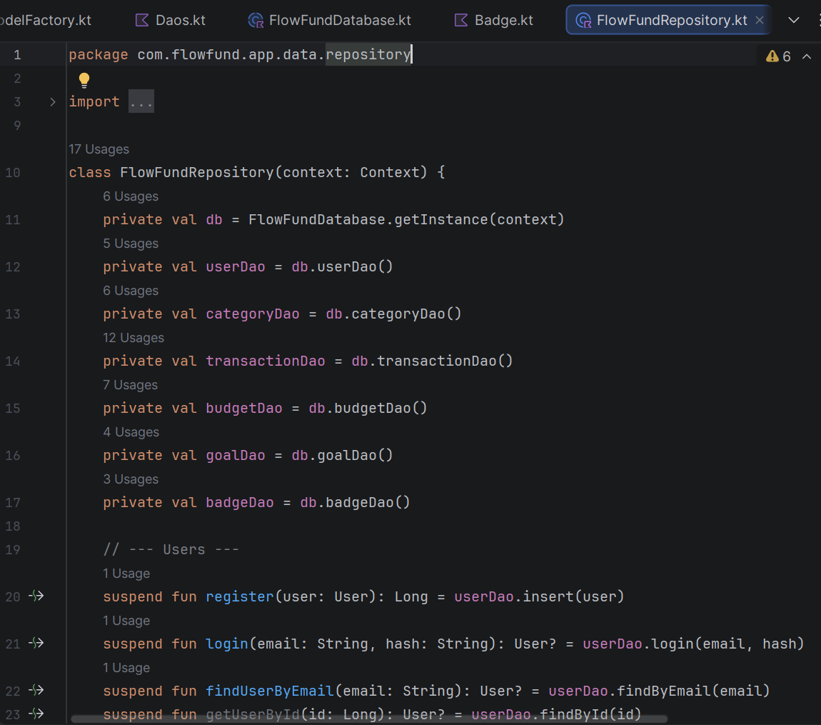
Figure 3: This code creates the FlowFund Repository, which acts as a link between the app and the database. It manages all data-related operations, including users, categories, transactions, budgets, goals, and badges. The repository provides functions to add, update, delete, and retrieve information from the database, making it easier for the rest of the application to access and manage data without directly interacting with the database.

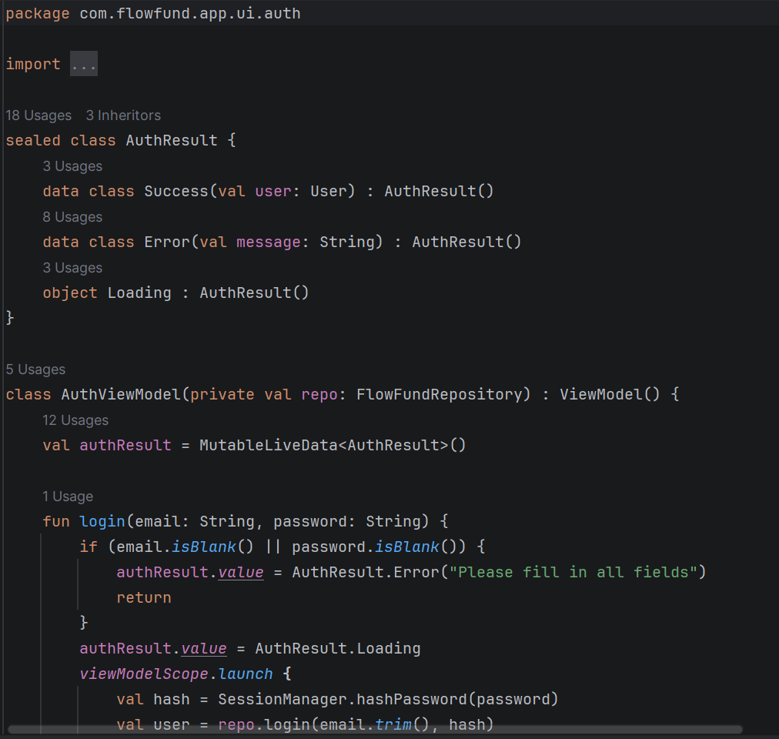
Figure 4: This code creates the AuthViewModel, which manages user login and registration. It validates user input, checks for errors such as empty fields, invalid email addresses, or mismatched passwords, and communicates with the repository to access user data.

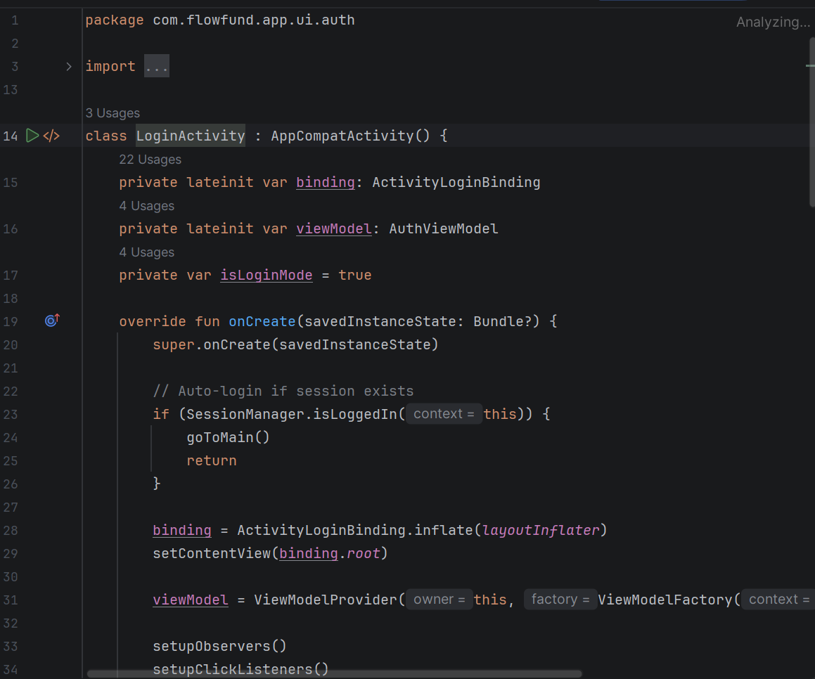
Figure 5: This code creates the LoginActivity, which handles user login and registration. It checks if a user is already logged in, allows users to switch between login and registration screens, and sends user details to the AuthViewModel for verification. It also displays loading indicators and error messages, saves the user's session after successful login, and opens the main application screen.

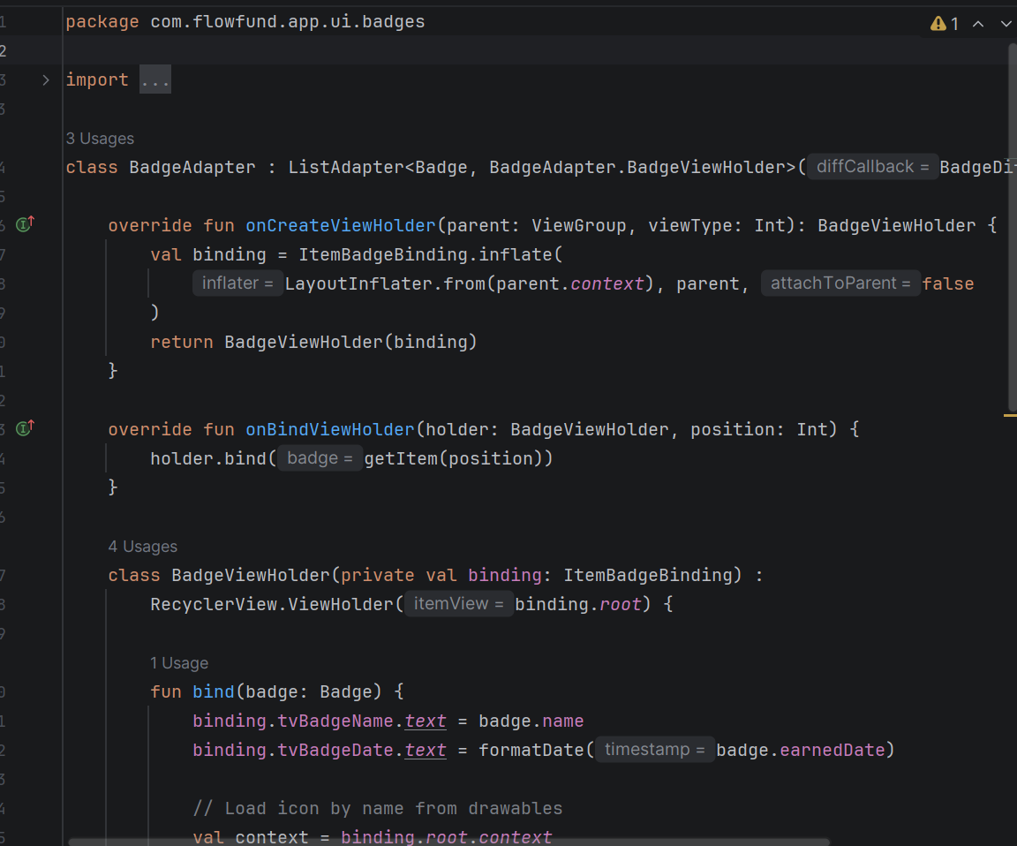
Figure 6: This code creates a BadgeAdapter for displaying badges in a RecyclerView. It loads badge information such as the badge name, date earned, and icon, and displays them in a list. The adapter also uses DiffUtil to efficiently update the list when badge data changes, improving the app's performance.

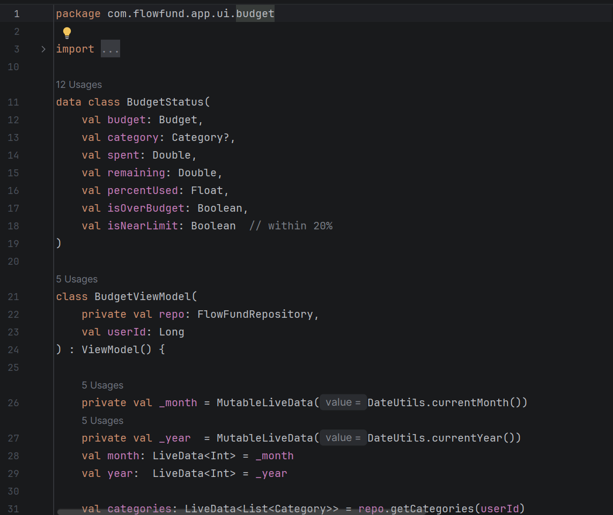
Figure 7: This code creates the BudgetViewModel, which manages budget-related data and business logic in the app. It loads and tracks budgets, calculates spending, remaining amounts, and budget usage percentages, and updates the user interface with this information. The ViewModel also allows users to create, update, and delete budgets, while checking whether spending stays within budget limits. Additionally, it automatically awards a Budget Master badge when a user remains within their overall budget for a month.

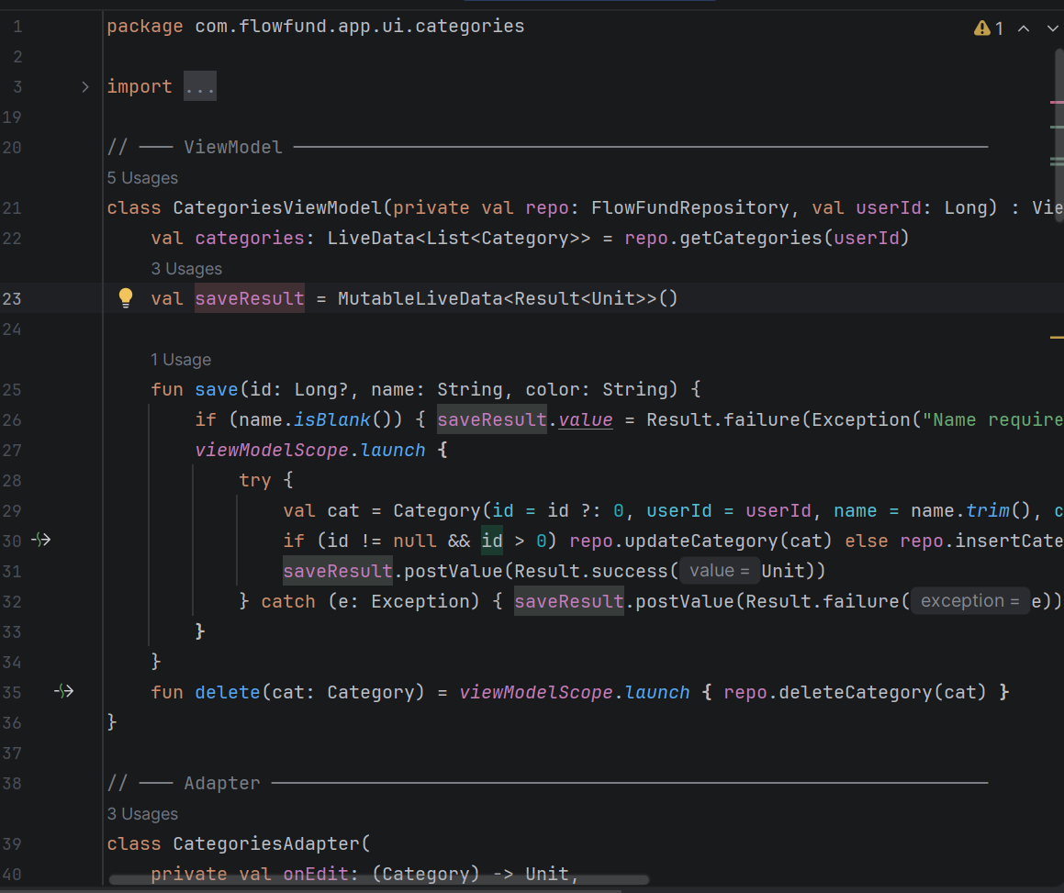
Figure 8: This code creates the Categories feature of the application. It allows users to add, edit, view, and delete spending categories, as well as choose a colour for each category. The ViewModel manages category data, the Adapter displays categories in a RecyclerView, and the Fragment provides the user interface, including forms and confirmation dialogs for managing categories.

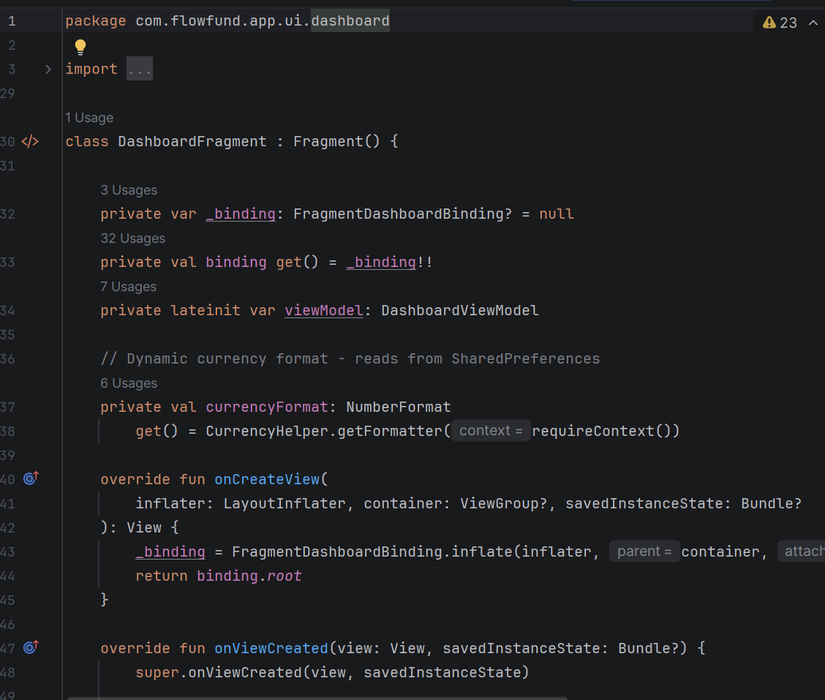
Figure 9: This code creates the DashboardFragment, which serves as the main dashboard of the FlowFund app. It displays the user's financial summary, including total income, expenses, and balance. The fragment uses pie charts and bar charts to visualize spending patterns and budget performance, provides personalized financial advice, tracks savings goals, and allows users to select different months to view financial data. It also includes navigation to the settings screen and a logout option.

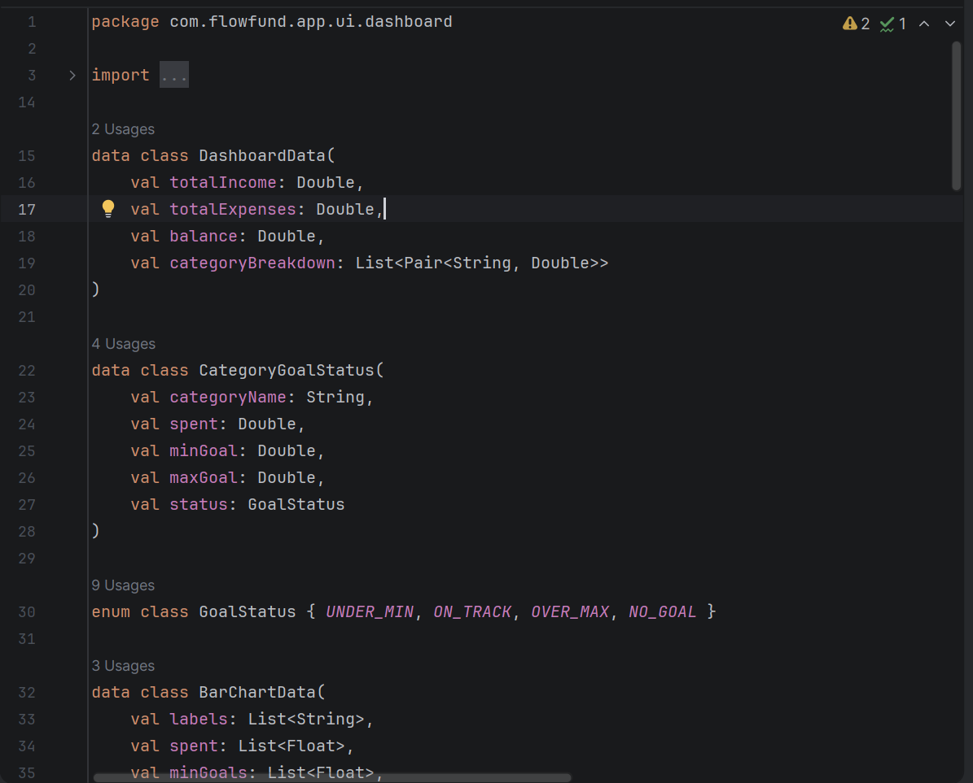
Figure 10: This code creates the DashboardViewModel, which prepares and manages financial data for the dashboard screen. It calculates total income, expenses, account balance, and spending by category for a selected month. The ViewModel also tracks budget goals, determines whether spending is on track or over budget, generates data for charts and graphs, and provides personalized spending advice based on the user's financial activity.

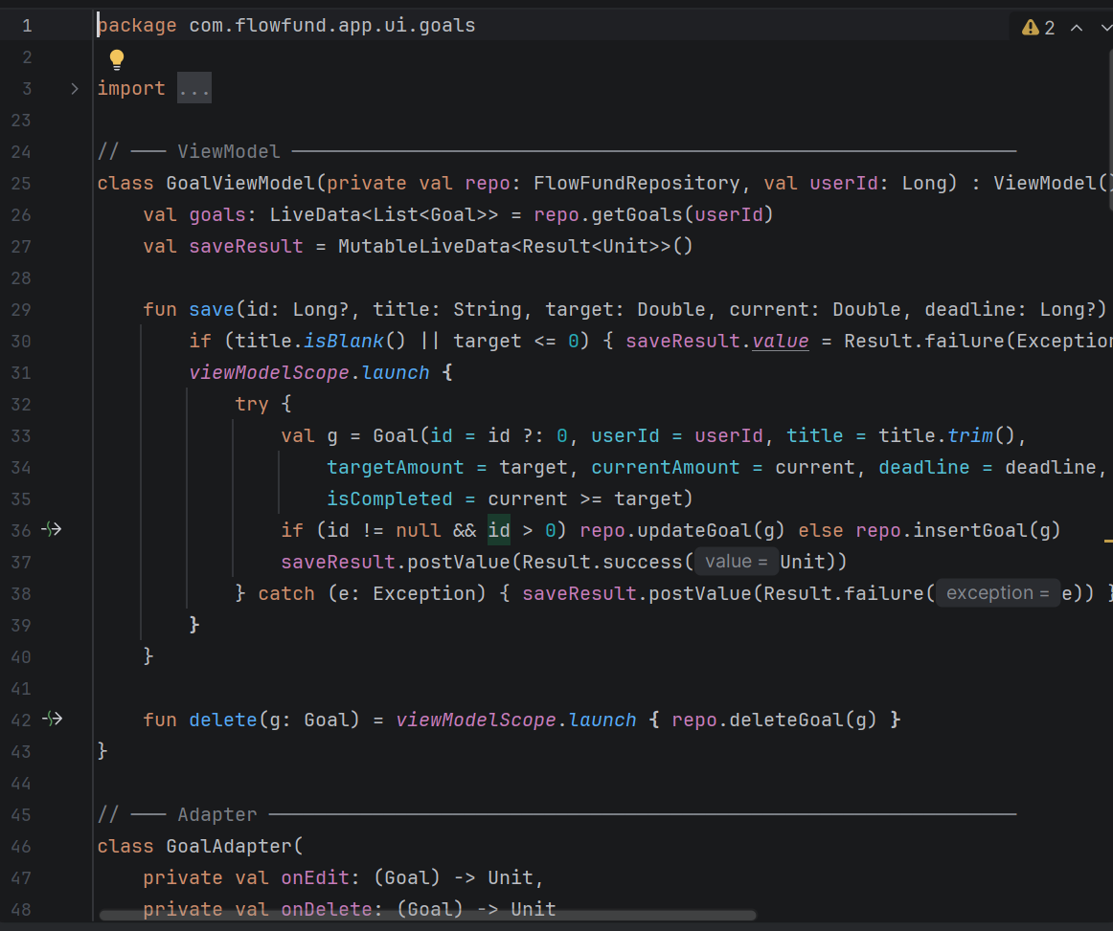
Figure 11: This code creates the Goals feature of the FlowFund application. It allows users to create, edit, view, and delete financial goals, set target amounts and deadlines, and track their progress. The feature displays each goal's completion percentage using a progress bar and automatically marks goals as completed when the target amount is reached, showing a "Goal Achieved" badge. The ViewModel manages goal data, the Adapter displays goals in a list, and the Fragment provides the user interface for managing goals.

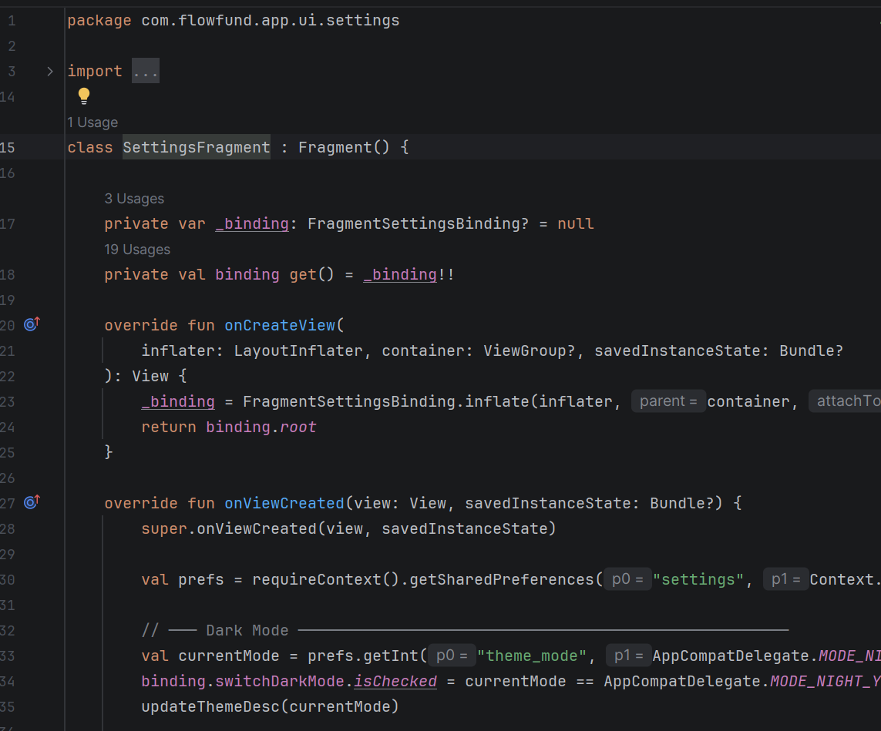
Figure 12: This code creates the Settings screen of the FlowFund application. It allows users to customize their experience by enabling or disabling dark mode and selecting their preferred currency. The settings are saved using SharedPreferences so they remain available when the app is reopened. The screen also includes an expandable section that provides information about the badge system and how badges are earned.

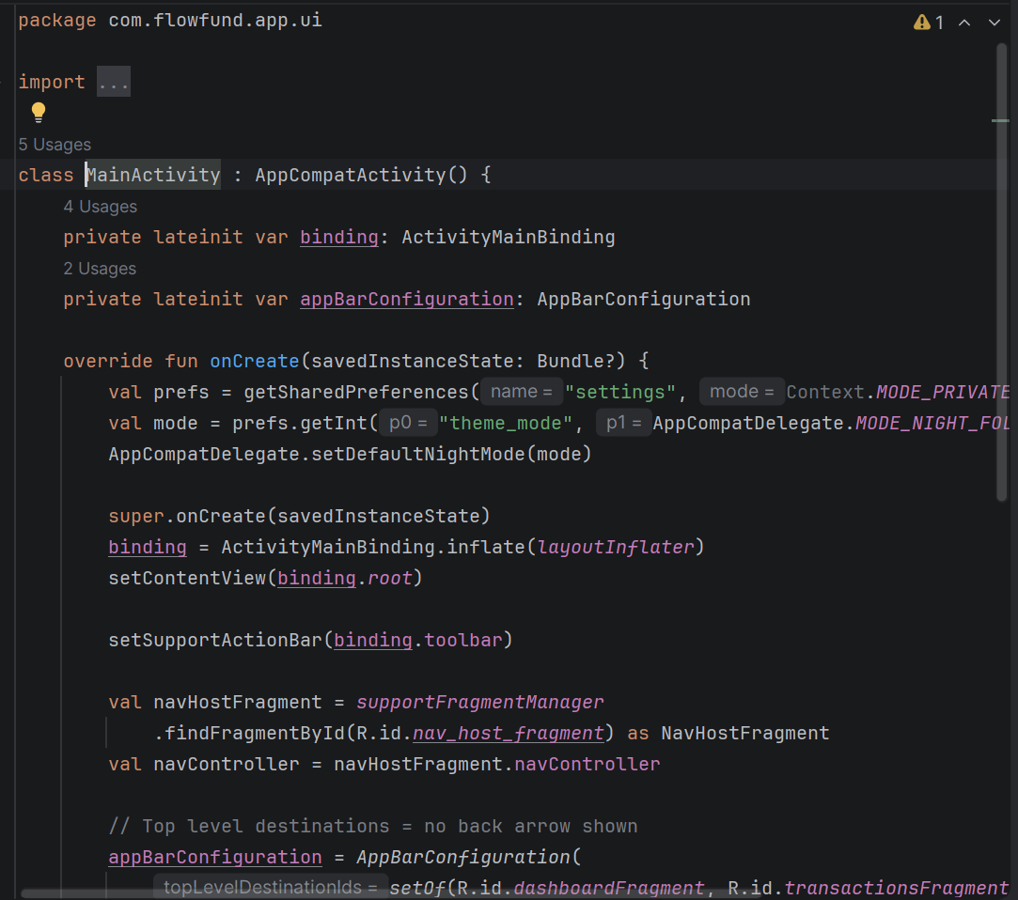
Figure 13: This code creates the MainActivity, which serves as the main screen and navigation hub of the FlowFund application. It loads the user's saved theme settings, sets up the toolbar and bottom navigation menu, and manages navigation between different sections such as the dashboard, transactions, and goals. It also includes a logout function that clears the user's session and returns them to the login screen.

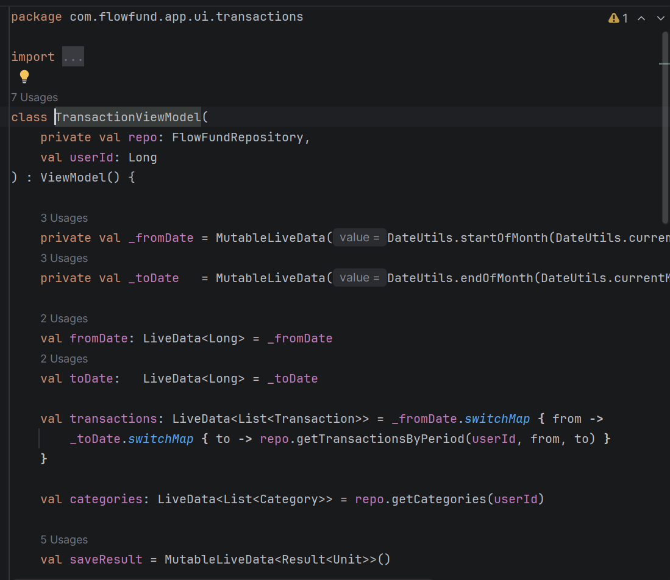
Figure 14: This code creates the TransactionViewModel, which manages transaction data for the application. It allows users to add, update, view, and delete transactions while validating transaction details such as the amount entered. The ViewModel also loads transactions for a selected date range, provides access to available categories, and communicates with the repository to store and retrieve transaction information from the database.

Conclusion
The FlowFund mobile application was successfully developed to help users manage their personal finances in an organized and user-friendly manner. The system provides features for user authentication, transaction tracking, budget management, category organization, financial goal setting, badge rewards, and dashboard reporting. Using Android Studio, Kotlin, and the Room database, the application securely stores and manages financial data while providing meaningful insights through charts, progress tracking, and personalized advice. Overall, FlowFund offers a practical solution for improving financial awareness, encouraging responsible spending habits, and helping users achieve their financial goals.

References

Microsoft (2026) Microsoft Word – Word Processing Software. Available at: https://www.microsoft.com/microsoft-365/word (Accessed: 8 June 2026).
Microsoft (2026) Android Studio – Official IDE for Android Development. Available at: https://developer.android.com/studio (Accessed: 8 June 2026).

